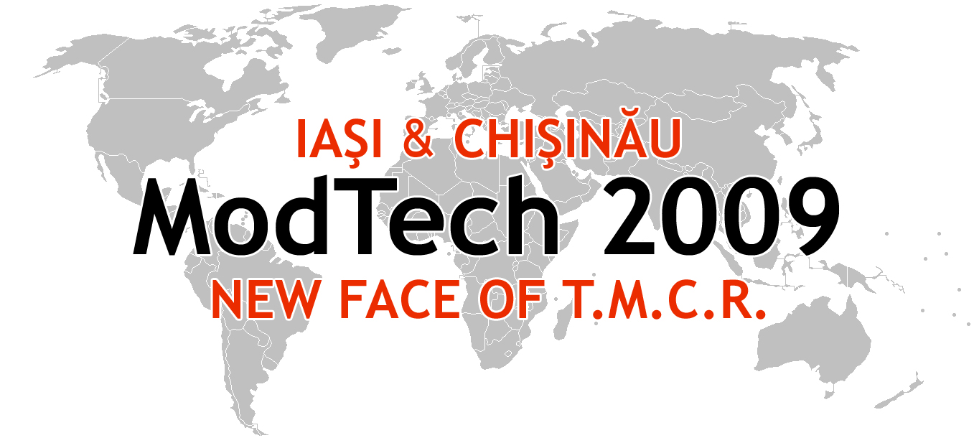

ModTech International Conference - New face of TMCR
Modern Technologies, Quality and Innovation - New face of TMCR
21-23rd May 2009
http://www.modtech.ro
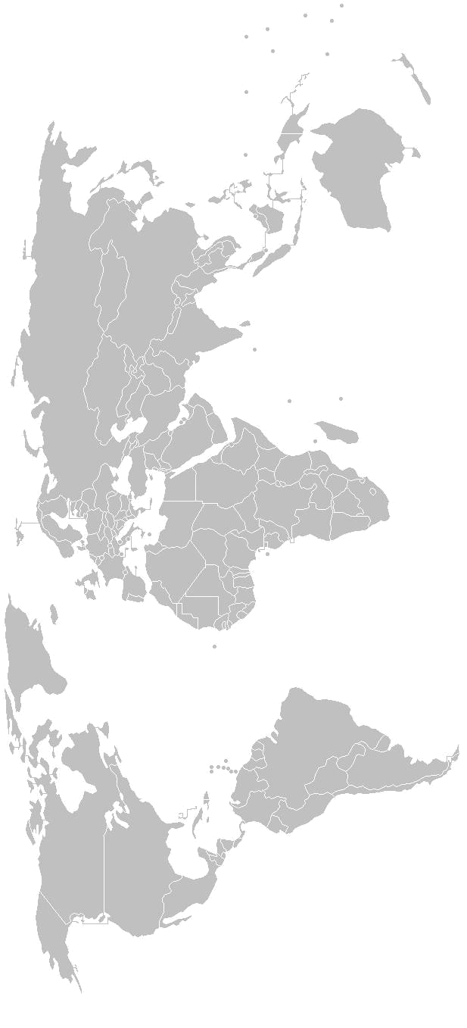
SECTION 6
Project Management

A-3-07, Laboratory of Project Management

Chair: Prof. Eugen Axinte, Ph.D.
Co-Chair: Assist. Margareta Coteata
Secretary: Ciprian Popa, Ph.D. Student

Thursday  May 21 | Papers & Authors
15²⁰-15³⁵ | The use of critical path methods in management of the repair activities  Florin Blaga, Traian Buidoş, Iulian Stănăşel & Alin Pop
15³⁵-15⁵⁰ | Improving the casting production cycle using kaizen concept  Florin Buruiana, Mihaela Banu, Alexandru Epureanu, Alice Buruiana
15⁵⁰-16⁰⁵ | Decision making process in project management  Romeo-Mihai Ciobanu & Lucian Tabacaru
16⁰⁵-16²⁰ | Business integrated manufacturing model  Daniela Ghelase, Luiza Daschievici, Alexandru Epureanu & Constantin Falticeanu
16²⁰-16³⁵ | Quality assurance for the glove manufacturing  Florentina Harnagea
16³⁵-16⁵⁰ | Base elements concerning the organization of stock management within logistic systems using multi-agent paradigms  Camelia Lixandru, Grămescu Traian & Roberto Teti
16⁵⁰-17⁰⁵ | Some crm principles and strategies applied in branding an institution of engineering education  Vasile V. Merticaru & Melike Demirbag Kaplan
17⁰⁵-17²⁰ | About plm systems as automation tools for concurrent engineering activities  Vasile V. Merticaru, Gavril Muscă & Elena Muscă
17²⁰-17³⁵ | The organization of the future: the creative organization  Gina-Maria Moraru & Monica Cojocaru
17³⁵-17⁵⁰ | Aspects of innovative strategies  Gina-Maria Moraru & Monica Cojocaru
17⁵⁰-18⁰⁵ | Aircraft performance improvements by using new concept of adaptive wing  Camelia Niculiţă, Ioan Cândea & Andrei Bencze
18⁰⁵-18²⁰ | Educational methodologies in engineering distance education  Carmen Cătălina Rusu, Luigi Renato Mistodie
Friday  May 22 | Papers & Authors
9⁰⁰-9¹⁵ | The development of course contents used in engineering distance education  Carmen Cătălina Rusu, Luigi Renato Mistodie
9¹⁵-9³⁰ | Problem based learning - case study for automotive engineering  Venetia Sandu, Carol Ambrus
9³⁰-9⁴⁵ | The concept of ecodesing in university curricula for the field of industrial design  Magda Sficlea, Jeni Pralea & Monica Pop
9⁴⁵-10⁰⁰ | Robustness of systems- knowledge and uncertainty  Silvia Rominu, Oana Ionita
10⁰⁰-10¹⁵ | Management, innovation and cooperation in aerospace engineering  Virgil Stanciu, Dana-Cristina Toncu & Gheorghiţǎ Toncu
10¹⁵-10³⁰ | Premises for elaboration of the system of a technical education from 3 cycles  Petru Todos & Alexei Toca
10³⁰-10⁴⁵ | An analysis of the human motion using vibe functions  Mihai Tofan, Ioan Burcă,Virgil Mihălcică, Sorin Vlase, Eugenia Secară & Violeta Munteanu
10⁴⁵-11⁰⁰ | Mathematical models for the human body motions analysis  Mihai Tofan, Ioan Burcă, Mircea Mihălcică, Eugenia Secară, Romeo Hisom & Ionatan Popa

